# What is Devops?

Devops is a set of practices that combines software development (Dev) and IT operations (Ops). It aims to shorten the systems development life cycle and provide continuous delivery with high software quality.

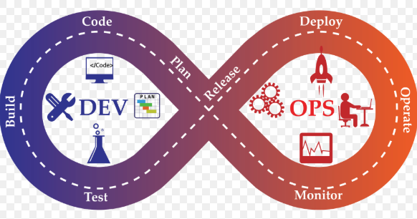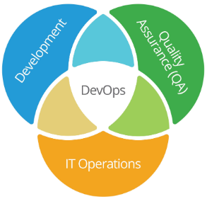

# Who all are involved in Dev and Operations team?

